**Minimax** is a decision-making algorithm , typically used in a turn-based,two player games.The goal of the algorithm is to find the best move for the player. To do so, we can just choose the node with best evaluation score. To make the process smarter, we can also look ahead and evaluate potential opponent’s moves.

In this algorithm, the recursive tree of all possible moves is explored to a given depth, and the position is evaluated at the ending “leaves” of the tree.

After that, we return either the smallest or the largest value of the child to the parent node. That is, we try to either minimize or maximize the outcome at each level,based of course on whether is black or white to move.

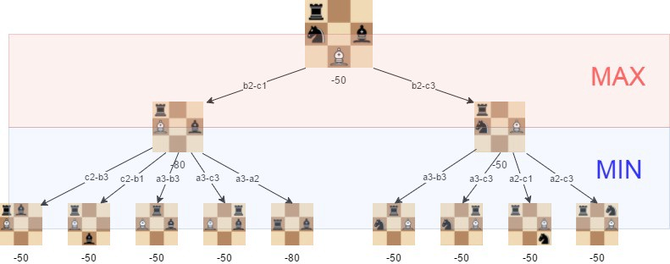 The picture above shows the visualization of the minimax algorithm in an artificial position.We can note that the best move for white is B2C3 ,because that guarantees a further position where the evaluation is -50.

The effectiveness of the minimax algorithm is heavily based on the search depth we can achieve.Therefore we’ll get into Alpha-beta pruning.

**Alpha-beta pruning** is an optimization method to the minimax algorithm that allows us to disregard some branches in the search tree. This helps us evaluate the minimax search tree much deeper, while using the same resources.

The alpha-beta pruning is based on the situation where we can stop evaluating a part of the search tree if we find a move that leads to a worse situation than a previously discovered move. It does not influence the outcome of the minimax algorithm — it only makes it faster. The alpha-beta algorithm also is more efficient if we happen to visit **first**those paths that lead to good moves.

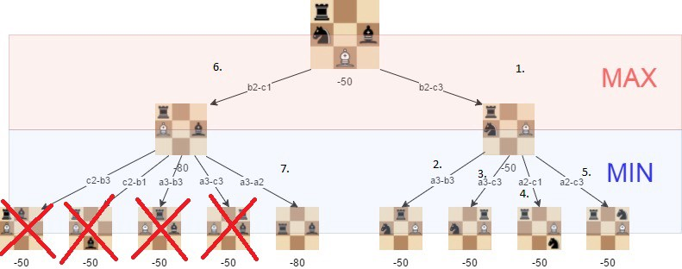

We can notice the positions we do not need to explore if alpha-beta pruning issued and the tree is visited in the described order .That means we no longer have to go more in depth on the disregarded branches and that clearly will improve the execution time.

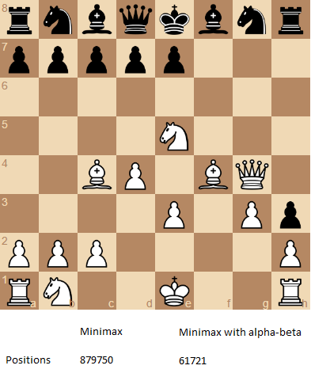

The number of positions that are required to evaluate if we want to perform a search with depth of 4 and the “root” position is the one that is shown.